CHAPTER 15

OPTIONS AND CONTINGENT CLAIMS

Objectives
- How to use options to modify one’s exposure to investment risk.
- To understand the pricing relationships that exist among calls, puts, stocks and bonds.
- To explain the binomial and Black-Scholes option-pricing models and apply them to the valuation of corporate bonds and other contingent claims.
- To explore the range of financial decisions that can be fruitfully analyzed in terms of options.

Outline

15.1 How Options Work
15.2 Investing with Options
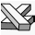
15.3 The Put-Call Parity Relation
15.4 Volatility and Option Prices
15.5 Two-State (Binomial) Option-Pricing
15.6 Dynamic Replication and the Binomial Model
15.7 The Black-Scholes Model
15.8 Implied Volatility
15.9 Contingent Claims Analysis of Corporate Debt and Equity
15.10 Credit Guarantees
15.11 Other Applications of Option-Pricing Methodology

Summary
- Options can be used to modify an investor’s exposure to investment risk. By combining the risk-free asset and stock-index call options, an investor can achieve a guaranteed minimum rate of return plus substantial upside participation in the stock market.
- A portfolio consisting of a stock plus a European put option is equivalent to a risk-free bond with a face value equal to the option’s exercise price plus a European call option. Therefore by the Law of One Price, we get the put-call parity relation:
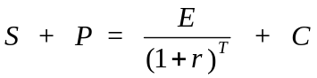
where S is the stock price, P the price of the put, r the risk-free interest rate, T the maturity of the option, and C the price of the call.
- One can create a synthetic option from the underlying stock and the risk-free asset through a dynamic replication strategy that is self-financing after the initial investment. By the Law of One Price, the option’s price is given by the formula:
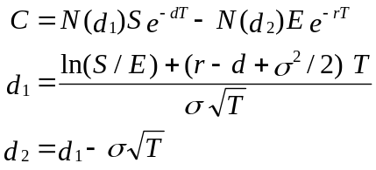

where:
C = price of the call
S = price of the stock
E = exercise price
r = risk-free interest rate (the annualized continuously compounded rate on a safe asset with the same maturity as the option)
T = time to maturity of the option in years
σ = standard deviation of the annualized continuously compounded rate of return on the stock
d = continuous dividend yield on the stock
ln = natural logarithm
e = the base of the natural log function (approximately 2.71828)
N(d₁) = the probability that a random draw from a standard normal distribution will be less than d₁.

- The same methodology used to price options can be used to value many other contingent claims, including corporate stocks and bonds, loan guarantees, and the “real options” imbedded in investments in research and development and flexible manufacturing technology.

Solutions to Problems at End of Chapter

Payoff Diagrams
- Graph the payoff for a European put option with exercise price E, written on a stock with value S, when:
- You hold a long position (i.e., you buy the put)
- You hold a short position (i.e., you sell the put)

SOLUTION:

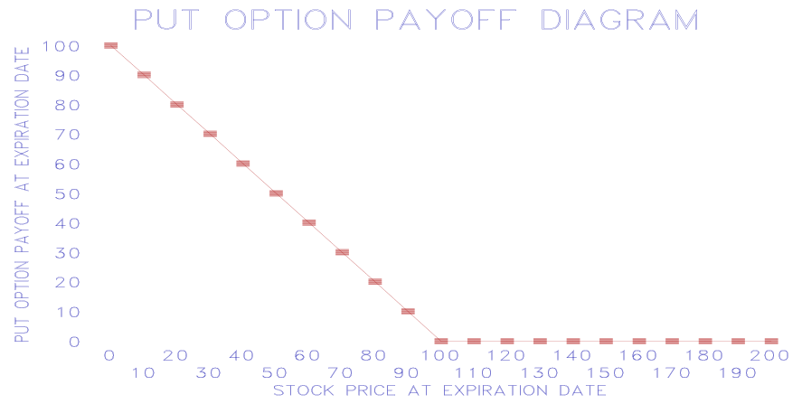
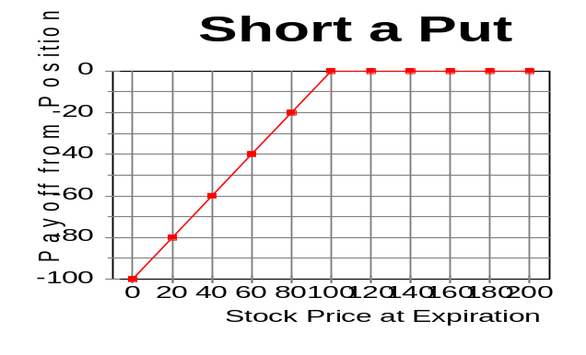
b.

- Graph the payoff to a portfolio holding one European call option and one European put option, each with the same expiration date and each with exercise price E, when both options are on a stock with value S.

SOLUTION:
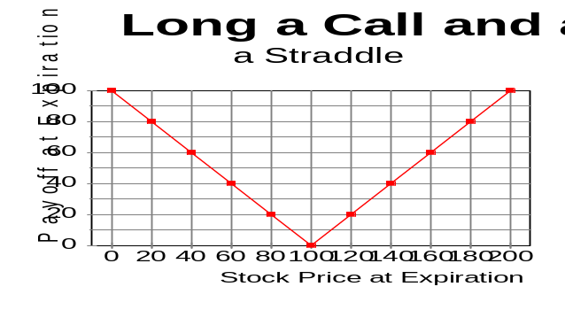

Investing with options
- The risk-free one –year rate of interest is 4%, and the Globalex stock index is at 100. The price of one-year European call options on the Globalex stock index with an exercise price of 104 is 8% of the current price of the index. Assume that the expected dividend yield on the stocks in the Globalex index is zero. You have $1million to invest for the next year. You plan to invest enough of your money in one-year T-bills to insure that you will at least get back your original $1 million, and you will use the rest of your money to buy Globalex call options.
- Assuming that you can invest fractional amounts in Globalex options, show the payoff diagram for your investment. Measure the Globalex index on the horizontal axis and the portfolio rate of return on the vertical axis. What is the slope of the payoff line to the right of an index value of 104?
- If you think that there is a probability of .5 that the Globalex index a year from now will be up 12%, a probability of .25 that it will be up 40%, and a probability of .25 that it will be down 20%, what is the probability distribution of your portfolio rate of return?

SOLUTION:

- 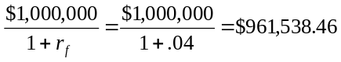To insure that you will at least get back your original $1 million, you need to invest
in T-bills.
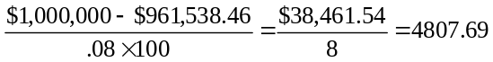You can buy
options.
The slope of the payoff line to the right of an index value of 104 is 4807.69, as seen from the graph:

- 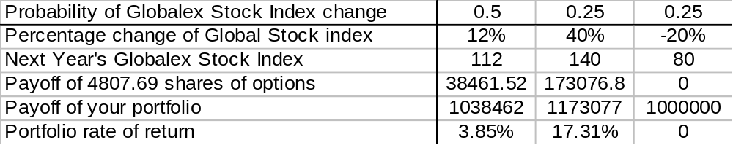

Put-Call Parity

- Show how one can replicate a one-year pure discount bond with a face value of $100 using a share of stock, a put and a call.
- Suppose that S=$100, P=$10, and C=$15. What must be the one-year interest rate?
- Show that if the one-year risk-free interest rate is lower than in your answer to part b, there would be an arbitrage opportunity. (Hint: The price of the pure discount bond would be too high).

SOLUTION:
- To replicate a one-year pure discount bond with a face value of $100, buy a share of stock, and a European put with exercise price $100, and sell a European call with an exercise price $100.
- S = $100, P = $10, and C = $15.
E/(1+r) = S + P- C
$100/(1+r) = $100 + $10 - $15 = $95
r = 100/95 -1 = .053 or 5.3%
- If r = 4%, then one could make risk-free arbitrage profits by borrowing at 4% and investing in synthetic 1-year pure discount bonds consisting of a share of stock, a European put with exercise price $100, and a short position in a European call with an exercise price $100. The synthetic bond would cost $95 and pay off $100 at maturity in 1 year. The principal and interest on the $95 it costs to buy this synthetic bond would be $95 x 1.04 = $98.8. Thus there would be a pure arbitrage profit of $1.20 per bond a year from now with zero initial outlay of funds.

- A 90-day European call option on a share of the stock of Toshiro Corporation is currently trading at 2,000 yen whereas the current price of the share itself is 2, 400 yen. 90-day zero-coupon securities issued by the government of Japan are selling for 9, 855 yen per 10, 000 yen face value. Infer the price of a 90-day European put option on this stock if both the call and put have a common exercise price of 500 yen.

SOLUTION:
Using the expression for put-call parity, P = -S + E/(1+r)^{T} + C
S is the share price, P is the price of the put, C is the price of the call and E is the common exercise price.
Since government bonds are selling at . 9855 per 1 yen of face value, this is the discount factor for computing the PV of the exercise price. There is no need to compute the riskless rate, r.
Substituting in the parity equation we get:
P = −2,400 + 500 x .9855 +2,000 = 92.75 yen

- Gordon Gekko has assembled a portfolio consisting of ten 90-day US Treasury bills, each having a face value of $1, 000 and a current price of $990.10, and 200 90-day European call options, each written on a share of Paramount stock and having an exercise price of $50.00. Gekko is offering to trade you this portfolio for 300 shares of Paramount stock, which is currently valued at $215.00 a share. If 90-day European put options on Paramount stock with a $50.00 exercise price are currently valued at $25.00,
- Infer the value of the calls in Gekko’s portfolio.
- Determine whether you should accept Gekko’s offer.

SOLUTION:
- Using put-call parity, the current price of a call is found to be approximately $190.50 as follows:
C = S − E/(1+r)^{T} + P = $215 − $50 x .9901 + $25 = $190.495
- The value of Gekko’s portfolio is 10 x $990.10 + 200 x $190.495 = $48,000
But the value of 300 shares is $64,500. We should reject Gekko’s offer.

- The stock of Kakkonen, Ltd., a hot tuna distributor, currently lists for $500.00 a share, whereas one-year European call options on this stock, with an exercise price of $200.00, sell for $400.00 and European put options with a similar expiration date and exercise price sell for $84.57.
- Infer the yield on a one-year, zero-coupon U.S. government bond sold today.
- If this yield is actually at 9%, construct a profitable trade to exploit the potential for arbitrage.

SOLUTION:
- Using put-call parity, we can infer the riskless yield to be approximately 8.36% as follows:
A portfolio consisting of a share of the stock, a put, and a short position in a call is equivalent to a 1-year T-bill with a face value of E. Therefore the price of such a T-bill would have to be $184.57:
E/(1+r)^{T} = S + P− C = $500.00 +$84.57 −$400.00 = $184.57
1+r = 200/184.57 = 1.0836
r = .0836 or 8.36%
- There are many ways to exploit the violation of the Law of One Price to make arbitrage profits. Since the risk-free interest rate is 9%, and the implied interest rate on the replicating portfolio is 8.36%, we could go short the replicating portfolio and invest the proceeds in T-bills. For example, at current prices, short-sell a “unit” portfolio, which consists of long positions in one put and one share and writing one call, to earn immediate revenue of $184.57. The portfolio you sold short requires payment of $200 one year from now. If you invest the $184.57 in one-year T-bills you will have 1.09x $184.57 = $201.18 a year from now. Thus you will earn a risk-free arbitrage profit of $1.18 with no outlay of your own money.

Two-State Option Pricing
- Derive the formula for the price of a put option using the two-state model.

SOLUTION:
To price the put option, we create a synthetic option by selling short a fraction (denote the fraction “a”) and lend $b in risk-free asset. Denote the price of the stock S, the price of the put option P, the stock price when the next period is an “up” to be uS, the stock price when the next period is a “down” to be dS, the payoffs of the put option in each state Pu and Pd, and the risk-free interest r.

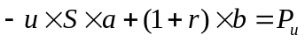We solve for (a, b) in 1)
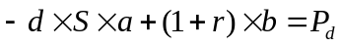and 2)
We find:
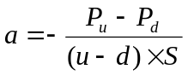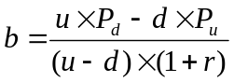and
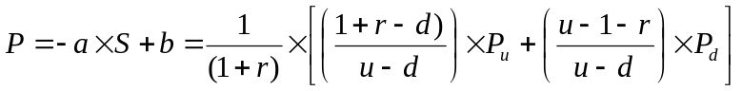So that the price of the put option

- The share value of Drummond, Griffin and McNabb, a New Orleans publishing house, is currently trading at $100.00 but is expected, 90 days from today, to rise to $150.00 or to decline to $50.00, depending on critical reviews of its new biography of Ezra Pound. Assuming the risk-free interest rate over the next 90 days is 1%, can you value a European call option written on a share of DGM stock if the option carries an exercise price of $85.00?

SOLUTION:
Should the value of DBM stock rise to $150 in 90 days, the call will be worth $65.00 at that date, but if DBM stock falls to $50.00 the call will be worthless at expiration. Using the 2-state option pricing model, we find that the call is worth $32.82:
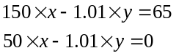To replicate the call using the stock and risk-free borrowing we buy x shares of stock and borrow y. We find
the values for x and y by setting up two equations, one for each of the possible payoffs of the call at expiration:
The solution to this set of two equations is x = .65 and y = $32.50/1.01 = $32.18
Thus, we can replicate the call option by buying .65 of a share of stock (at a cost of $65) and borrowing $32.18.
The price of the call option is $32.82:
C = .65 x $100 - $32.18 = $32.82

The Black-Scholes Formula

- Use the Black-Scholes formula to find the price of a 3-month European call option on a non-dividend- paying stock with a current price of $50. Assume the exercise price is $51, the continuously compounded risk-free interest rate is 8% per year, and σ is .4.
- What is the composition of the initial replicating portfolio for this call option?
- Use the put-call parity relation to find the Black-Scholes formula for the price of the corresponding put option.

SOLUTION:
- The price of the call is $3.987. Since the present value of the exercise price is approximately equal to the current stock price, we could use the linear approximation to the Black-Scholes formula:

- The hedge ratio, which is the number of shares of stock you must buy, equals N(d1), and the amount to borrow is N(d2) times the PV of the exercise price. To find N(d1) and N(d2) you must compute d1 and d2 and then apply the N( ) function (i.e., the standard normal cumulative density function). You can either use NORMDIST in Excel or use a statistical table to do this. The hedge ratio is .54, which means you would buy .54 of a share of stock for $27. The amount to borrow is $23.
c. From put-call parity: P = −S + E e^{0.02} + C = −$50 + $51.01 + $4 = $5.01

- As a financial analyst at Yew and Associates, a Singaporean investment house, you are asked by a client if she should purchase European call options on Rattan, Ltd. stock, which are currently selling in U.S. dollars for $30.00. These options have an exercise price of $50.00. Rattan stock currently exhibits a share price of $55.00, and the estimated rate of return variance of the stock is .04. If these options expire in 25 days and the risk-free interest rate over that period is 5% per year, what do you advise your client to do?

SOLUTION:
We can apply the Black-Scholes formula, where S = $55, E = $50, σ = .2, T = 25/365, r = .05. We find that
C = $5.20. This is a lot less than $30, so clearly the options are not worth buying.

Valuation of Corporate Securities with the Two-State Model
- Lorre and Greenstreet, Inc., a purveyor of antique statues, currently has corporate assets valued at $100,000 and must repay $50, 000, the aggregate face value of zero-coupon bonds sold to private investors, in 90 days. An independent appraisal of a newly acquired antique falcon from Malta will be publicly released at that time, and the value of the firm’s assets is expected to increase to $170,000 if the falcon is certified as genuine, but to decline to a mere $45, 000 if the antique is found to be a fake. The firm will declare bankruptcy in this latter circumstance and shareholders will surrender the assets of the firm to its creditors.
- Can you express the current aggregate value of equity in Lorre and Greenstreet as a contingent expression of the value of the firm’s assets and the face value of its outstanding debt?
- Is there a relation between the expression you have derived for equity and a 90-day European call option written upon the aggregate value of the firm’s assets?
- Can you express the current aggregate value of the bonds issued by Lorre and Greenstreet in terms of the value of the firm’s assets and the face value of its outstanding debt?
- Is there a relation among the current value of the bonds the firm has issued, the current value of riskless bonds with the same term to maturity and face value, and a European put option written on the aggregate value of the firm’s assets? What would the implication of such a relationship be for expressing the value of risky debt in terms of risk-free debt and collateral?

SOLUTION:
- The aggregate value of the firm’s equity in 90 days is E1 = max (V1 −B, 0) where E1 and V1 are, respectively, the aggregate values in 90 days of the firm’s equity and assets, and where B is the aggregate face value of the firm’s debt.
The current value of the equity can be expressed as:
E = xV − y

where x is the fraction of the value of the firm that one must purchase to replicate the payoffs from the equity, and y is the amount that must be borrowed. We find the values for x and y by setting up two equations, one for each of the possible payoffs of the equity 90 days from now:
170000x − y(1+r) = 120,000
45000x − y(1+r) = 0
The solution to this set of two equations is x = 120/125 = .96 and y = $43,200/(1+r), where r is the risk-free 90-day interest rate. Thus, we can replicate the equity by buying 96% of the firm’s assets (at a cost of $96,000) and borrowing the present value of $43,200. The current value of the equity is therefore:
E = $96,000 −$43,200/(1+r)
- They are exactly analogous. The call value is analogous to the aggregate value of equity, the share price is analogous to the aggregate value of the firm’s assets, and the exercise price is analogous to the face value of the firm’s debt. In effect, the firm’s shareholders hold a call option on the firm’s assets, which they can exercise by repaying the face value of the debt.
- In the presence of limited corporate liability, the realized aggregate payoff to the firm’s creditors in 90 days, D₁, can be written as:
D₁ = min (V₁,B).
- The difference in value between the firm’s bonds and the corresponding default-free bonds equals the value of a European put on the firm’s assets. This relation implies the limited liability that stockholders have to sell the firm’s assets at the debt’s face value, which also implies that the value of risk-free debt equals the sum of the value of the risky debt and the value of collateral.

- Gephardt, Army and Gore, a vaudeville booking agency, has issued zero-coupon corporate debt this week, consisting of 80 bonds, each with a face value of $1,000 and a term to maturity of one year. Industry analysts predict that the value of GAG assets will be $160,000 in one year if Rupert Murdoch succeeds in purchasing and converting the Washington Press Club into a comedy venue, $130,000 if Murdoch buys the club but retains its current scheduling, and $20,000 if Murdoch builds an alternative comedy venue in Washington. Industry analysts also predict that aggregate value of the assets of a second firm in the field of comedy entertainment, Yelstin Yuks, Ltd., will have the values of $100,000, $100,000, and $40,000 in these respective circumstances. Assuming that investors can purchase portfolios comprised of shares of the assets of GAG and YY Ltd., as well as buying or short –selling one-year, zero-coupon, government bonds at the risk-free annual rate of .10, then
- Infer the three alternative values for aggregate equity in GAG, one year from today.
- Devise a portfolio that is a perfect substitute for the payoffs given by a portfolio composed only of equity in GAG.
- Determine the current market value of a share of equity in GAG, assuming 10,000 shares of GAG stock are outstanding, the current market value of GAG assets is $120,000, and the current market value of YY Ltd., assets is $85,725.
- Determine the current market value of a bond issued by GAG, assuming 80 bonds are issued, under these circumstances. What of the yield to maturity on each such bond?

SOLUTION:
- In the first circumstance, the value of aggregate equity in GAG is $160,000-$80,000=$80,000.
In the second circumstance, the value of aggregate equity in GAG is $130,000-$80,000=$50,000.
In the third circumstance, the value of aggregate equity in GAG is 0.
- Suppose that the replicating portfolio consists of buying x units of the GAG asset, y units of the YY asset, and z units of the government bond (with a face value of $100,000). The payoff of this portfolio will exactly match that of the GAG equity, that gives:
160,000x + 100,000y + 100,000z = 80,000
130,000x + 100,000y + 100,000z = 50,000
20,000x + 40,000y +100,000z = 0
solving the equations, we have x = 1, y = -1, z = 0.2
- We define three types of pure contingent claims: at the end of one year, AD1 will pay off $1 if and only if Rupert Murdoch succeeds in purchasing and converting the Washington Press Club into a comedy venue; AD2 will pay off $1 if and only if Murdoch buys the club but retains its current scheduling; AD3 will pay off $1 if and only if Murdoch builds an alternative comedy venue in Washington. Denote the prices as of today of the three pure contingent claims as p₁, p₂ and p₃, respectively.
From the value equation of the GAG asset, YY asset and the government bond, we have:
GAG: 160,000p₁ + 130,000p₂ + 20,000p₃ = 120,000
YY: 100,000p₁ + 100,000p₂ + 40,000p₃ = 85,725
Government bond: 100,000p₁ + 100,000p₂ + 100,000p₃ = 100,000/(1+10%) = 90,909
Solve the equations, we have p₁ = 0.3774, p₂=0.4453, p₃=0.0864
The total value of GAG equity is
80,000p₁ + 50,000p₂ = $52457
The per share price of equity is $5.25.
- The value of the bond and the value of the equity add up to the value of the asset, so,
V_{bond} = V_{asset} – V_{equity} = 120,000 – 52547 = $67543
The yield-to-maturity of bond is (80,000-67543)/67543 = 18.4%

